NEWENT TOWN COUNCIL
AND BURIAL AUTHORITY

Annexe Building
Rear of Newent Community Centre
Ross Road
Newent
Gloucs. GL18 1BD

Tel: 01531 820638
Email:townclerk@newenttowncouncil.gov.uk
www.newenttowncouncil.org.uk
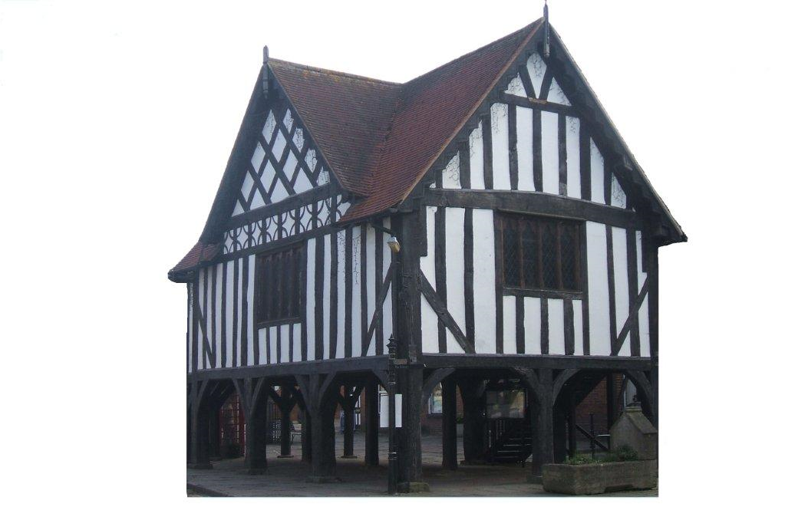

APPLICATION FORM FOR GRANT(S)AND/OR DONATION(S)

1. | Name of Organisation
2. | Contact and Position held in the Organisation
3. | Address
4. | Telephone Number of Contact (daytime)
5. | Aims and Purpose of the Organisation
6. | Is the Organisation a Registered Charity?  If Yes, please supply Charity No.  Is the Organisation not for profit? | Yes/No  Yes/No
7. | Amount of grant requested | £
8. | For what purpose or project is the grant requested?
9. | What will be the total cost of the above project? | £
10. | If the total cost of the project is more than the grant, how will the residue be financed?
11. | Have you applied for a grant for the same project to another organisation?  If so, which organisation and how much?
12. | Who will benefit from the project?
13. | Approximately how many people or proportion of the people who would benefit live in the Newent Parish?
14. | Have you received a Newent Town Council grant within the previous two years? If so how much did you receive?
15. | Please confirm the number of cheque signatories required to authorise all payments/orders issued by your organisation
16. | If successful, name to whom the cheque should be made payable

All questions on this form must be completed, but you may also attach supporting information.

This application must be supported by a financial statement showing income and expenditure and balance sheet for the previous accounting year.

For new initiatives or activities, a copy of the budget forecast and business plan will be acceptable.

I hereby apply for a Newent Town Council grant for the above organisation and I confirm that the information given above is to the best of my belief correct:

Signed……………………………………………………………….Date……………………………………

Name (in capitals)……………………………………………………………………………………………..

The completed form and supporting papers should be sent to:
The Town Clerk, Newent Town Council, Annexe Building, rear of Newent Community Centre,
Ross Road, Newent, Gloucs. GL18 1BD.

