NEWENT TOWN COUNCIL
AND BURIAL AUTHORITY

Annexe Building
Rear Newent Community Centre
Ross Road
Newent
Gloucs. GL18 1BD

Tel: 01531 820638
Email:townclerk@newenttowncouncil.gov.uk
www.newenttowncouncil.org.uk
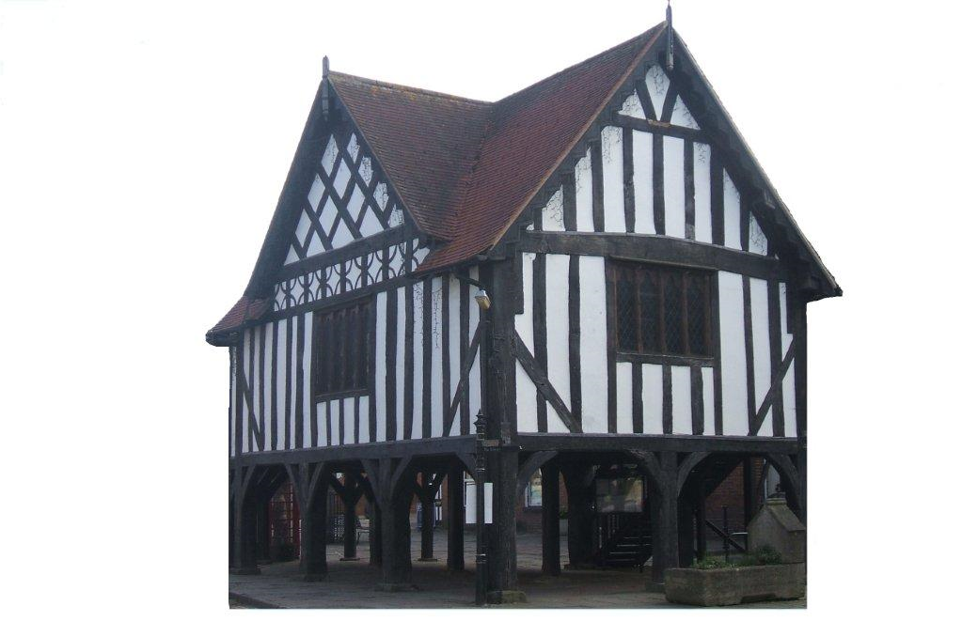

DEED OF VARIATION GRANT FUNDING APPLICATION

INFORMATION FORM

1. | Name of Organisation
2. | Contact and Position held in the Organisation
3. | Address
4. | Telephone Number of Contact (daytime)
5. | Aims and Purpose of the Organisation
6. | Is the Organisation a Registered Charity?  If Yes, please supply Charity No.  Is the Organisation not for profit? | Yes/No  Yes/NO
7. | Amount of grant requested | £
8. | What will be the total cost of the above project? | £
9. | Please confirm the number of cheque signatories required to authorise all payments/orders issued by your organisation
10. | If successful, name to whom the cheque should be made payable

All questions on this form must be completed along with a detailed business case. Any omissions will result in the application being rejected.

I hereby apply for a grant from the Deed of Variation monies, for the above organisation and I confirm that the information given above and on the completed Schedule 1 - Business Case Form is, to the best of my belief, correct:

Signed……………………………………………………………….Date……………………………………

Name (in capitals)……………………………………………………………………………………………..

The completed forms should to be returned along with the Schedule 1 – Business Case Form to: The Town Clerk, Newent Town Council, Annexe Building, Rear Newent Community Centre, Ross Road, Newent, Gloucs. GL18 1BD.

